Incoming 9th Grade Summer Reading Assignment
English 9 with Mrs. Wagaman
Name: __________________________

Congratulations! You’re on your way to high school, but before you embark on this journey you must continue to train and strengthen your reading and writing stamina throughout the summer.

Reading Assignment: Read The Outsiders by S.E. Hinton. The Outsiders is about two weeks in the life of a 14-year-old boy. The novel tells the story of Ponyboy Curtis and his struggles with right and wrong in a society in which he believes that he is an outsider.

Copies of the book are available in the following ways:
- Borrowed from Sayre Area School District (limited number of copies available- first come first served.) See Mrs. Powers for a copy.
- Borrowed from the local library.
- $1-$3 on Amazon.com (with 3.99 shipping), or 5.91 with Prime
- Downloaded to a Kindle, Nook, iphone/ibooks – $9.99
- Audible.com has audiobooks – free 30 day trial, regular $14.95 a month

Other Assignments:
-Take notes on the novel – notes should be completed no later than September 6th.
-When you return to school one of your first assignments will be an in-class essay based on the notes you took during the summer.

What should I take notes on??
When you return to school the essay will be asking you to analyze the characterization, setting, symbols, motif, theme, or author’s purpose. You may also collect signposts (Memory Moments, Contrasts & Contradictions, or Words of the Wiser, etc.), and use those to show characterization, theme, etc. I would follow a couple of different ideas through the book so you have a good number of ideas for your essay.

How should I take notes??
It’s up to you, but here are two suggestions.
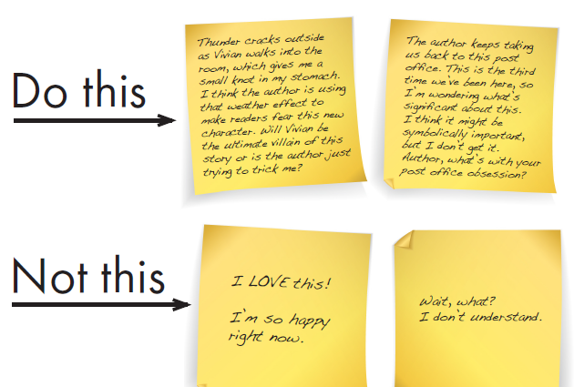
1. Use post-it notes. But when you do, don’t just respond to the book, but go deeper. This will help you later when you go to write your essay.
2. Make a Double-Entry Journal
On notebook paper, draw a line down 1/3 of the paper. On the left side, write down key lines from the novel WITH page numbers. On the right, respond to the quotes/passage with thoughts and analysis.

“Moishe was not the same. The The eyes might be a symbol that Wiesel is using
joy in his eyes was gone.” (p. 7) to show us into a character’s heart (eyes are the
window to the soul)

“I glanced over at my father. Ooh, there it is again. This time the eyes are
How changed he looked! His veiled – what is he hiding?
Eyes were veiled.” (p. 37)

HOUSE CUP COMPETITION
I’m a HUGE fan of the Harry Potter books. (I’ve always secretly wanted to be in Ravenclaw ). So in 9th grade I’ve created the House Cup Competition. At the beginning of the school year you will be sorted into a house. They are:

Dapperheim – students in this house are known for their courage and strength. Dapperheim means bravery in Dutch. Their colors are red and white.

Sonador – students in this house are known for their creativity and are dreamers. Sonador means dreamer in Spanish. Their colors are purple and ivory.

Pemberi – students in this house are known for their wisdom and loyalty. Pemberi means givers in Indonesian. Their colors are orange and black.

Urafiki – students in this house are known for their kindness and spreading harmony. Urafiki means friendship in Swahili. Their colors are turquoise and gray.

Each house will compete throughout the year for the house cup. Each marking period students can earn and lose points. One house is declared the winner each marking period and absolutely amazing prizes await the winner. The house that has the most points (add all 4 marking periods together + points from final exam review) wins the House Cup for the year.

You can earn Positive Points for:
  - Answering a difficult question in class, participating in class discussions, working well in groups, helping fellow students, review games, etc.
  - 5 points – 100% on quizzes, 10 points – 100% on tests
  - Independent Reading Program
    - If students take Accelerated Reader quizzes for their books (and get an 80% or higher), the number of points the book is worth will earn them that many house points.
    - For the independent reading program we will keep track of the number of pages read. You will be required to read an hour a week. We take the average for each house. The house with the highest average gets 200 points.
    - If you read more pages than Mrs. Wagaman in a marking period, you earn 10 points for your house.

Negative Points (I don’t want to have to use these!)
  - Being late (more than a minute or two) for class and / or being consistently late to class.
  - Coming to class unprepared – no pencil/asking me for pencil
  - Homework not being turned in on time
  - Using a cell phone or other electronics in class without permission.
  - Not paying attention in class (including, but not limited to, sleeping, holding side conversations, or doing work for other classes).
Prefects
  - In Harry Potter, several older students were chosen to be the leaders within the house. Their job was to kind of keep people in line, be the leader in an emergency, etc.
  - Each class period will choose a prefect for their house. This means there will be 16 prefects total. Their job duties will include:
    - Setting the example for others – this is a responsible student who always does their work and can help the others.
    - Be in charge of the ‘owerly’ – turning in and returning papers for their house. They will do this quietly and quickly at the start of class.
    - Reporting problems within the house to Mrs. Wagaman, only if they have not already tried to resolve the problem within the house.

Reading List
Students will have the opportunity to start earning points for their house early by choosing books from the provided reading list. I HIGHLY encourage all students, but especially college prep and honors students, to read at least one book from this list, in addition to The Outsiders.

The reading list was complied with the help of Mr. Meunch, with a focus on books that fit into the topics and themes that will be discussed in 9th Grade: Personal Journey, Mystery and the Future, Honor, Justice, Sacrifice, and Human Rights.

**Start earning points early by getting at least an 80% on AR Quizzes for any books on the summer reading list outside your required book!!**

-The AR points will become house points (ex: An Abundance of Katherines is worth 10 points)
-The test must be dated between June 15th and September 12thand you have to get at least an 80%
-You can earn ½ credit for books not on the list, but you also must take the AR Quiz or do a one-pager (which can be printed from my wikispace – SSR)

I highly encourage parents to review the book list and discuss these books with their students before they make their choices, as some may contain more mature themes and language.

Where can I get a copy of these books?
- Some of the novels are available to be borrowed from SHS. See Mrs. Wagaman in room 230. Books will be provided on a first come, first serve basis. There aren’t enough copies for everyone. (If you borrow a book and misplace it, you will be responsible for replacing it.)
- Visit your local Public Library to reserve your copy for free. Listed under the title is where you can find the book – either at our local Sayre Public Library, through the Bradford County Library System, or “get through power library.” If it is in the Bradford County Library System or available through power library, you can have it requested and sent to the Sayre Public Library for you to borrow. See Mr. Meunch if you have any questions on how this works.
- Purchase a new or used book on www.amazon.com.
- Purchase the e-text version for your electronic device. Electronic devices will be allowed for educational purposes in ENG-9.
- Barnes and Nobles in Elmira, NY, has this list and will make sure all books are on hand for purchase.

Questions? Concerns? Comments?
- Email Mrs. Wagaman @ awagaman@sayresd.org
- Visit our classroom webpage @ www.awagaman.wikispaces.com

